Fig (1): Frequency of congenital anomalies

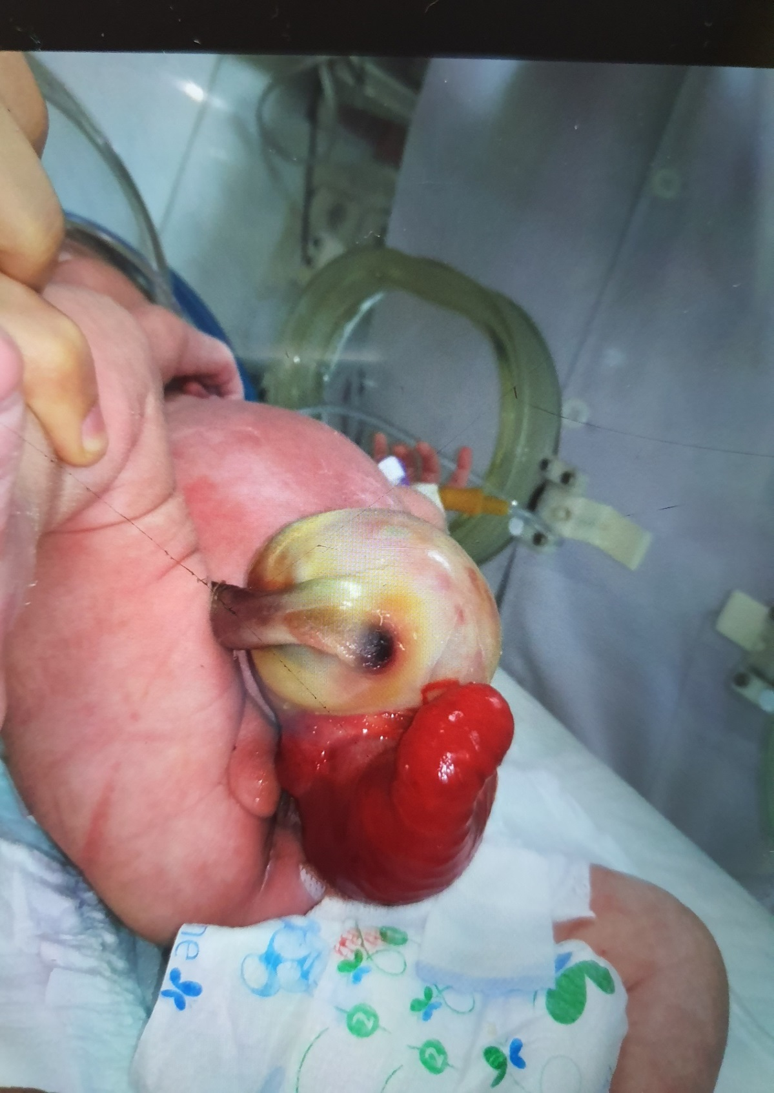

Fig. (2) Cloacal exstrophy

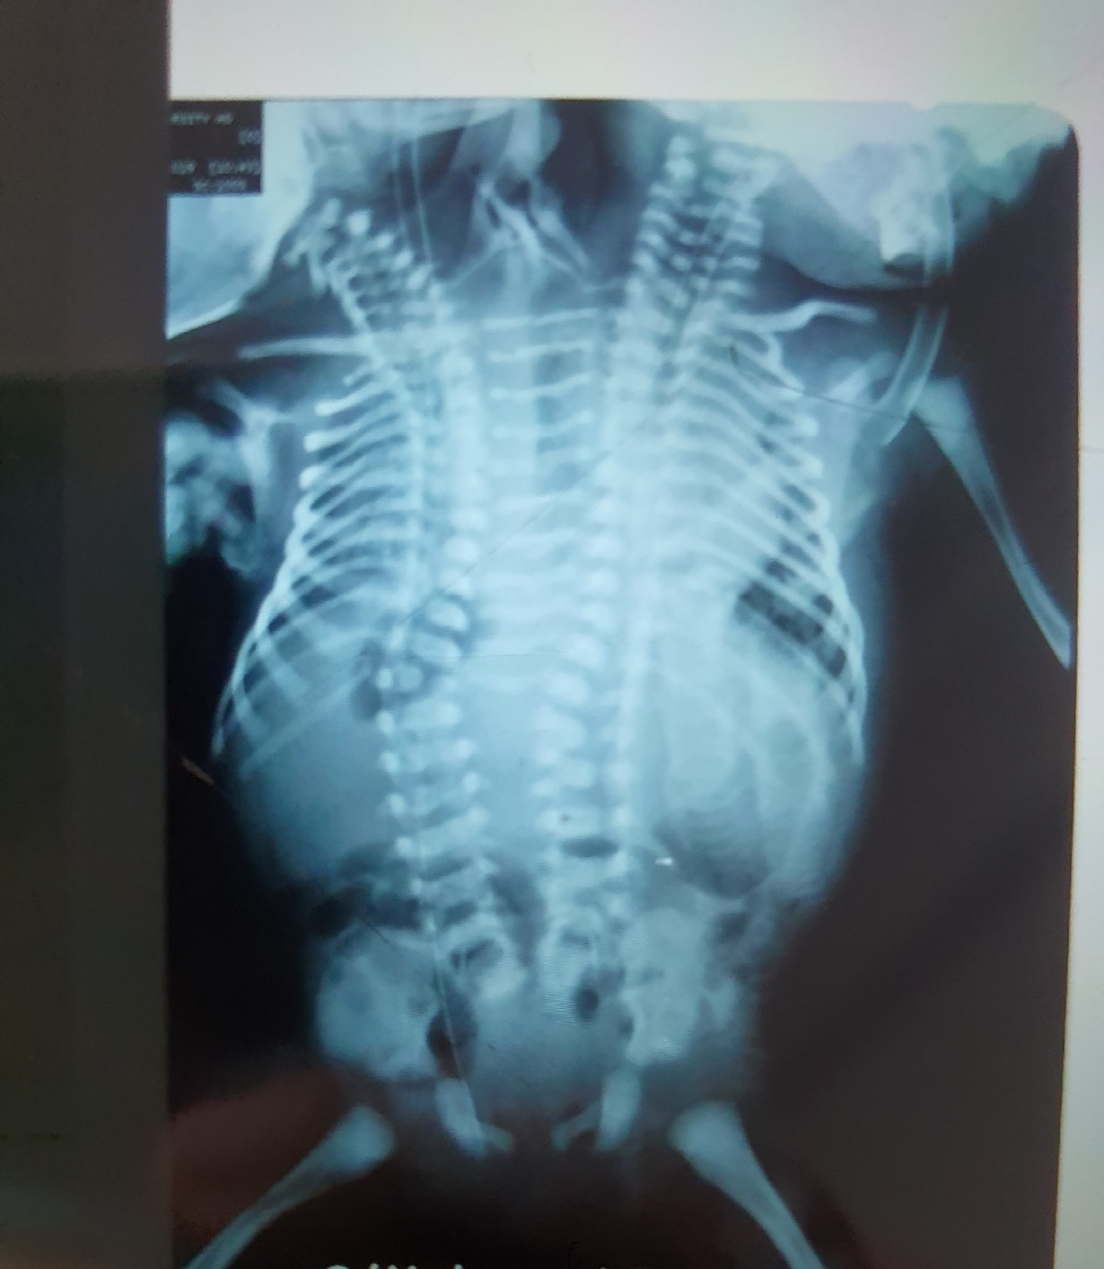

Fig. (3) X-ray of conjoined twins

Fig. (4) The Percentage of congenital anomalies

