**Figure (1): Comparison between patients cord & serum (5th -7th days) H2O2 levels and that of control cord blood (pg/ml).**

**Figure (2): Comparison between patients cord & serum (5th -7th days) bilirubin levels and that of control cord blood (mg/dl).**

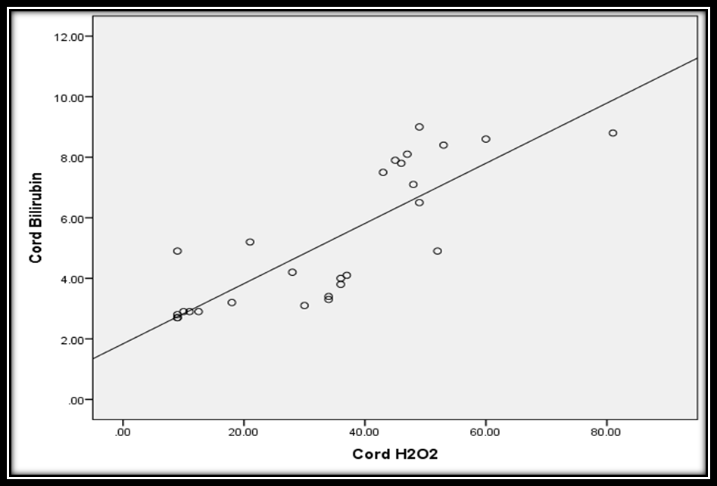 **Figure (3): Correlation between cord H2O2 (pg/ml) and cord bilirubin levels among all neonates (mg/dl)**

r=0.817

P<0.001*

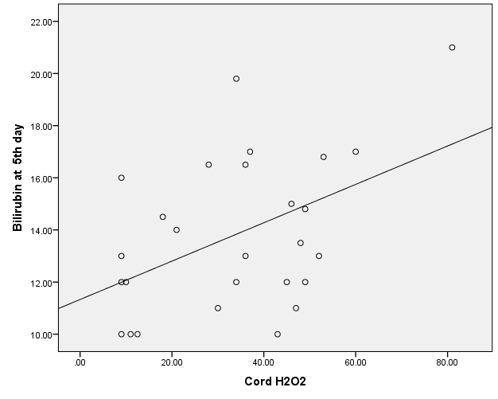

r=0.46

P<0.014*

**Figure (4): Correlations between cord H2O2 and 5th day bilirubin levels**

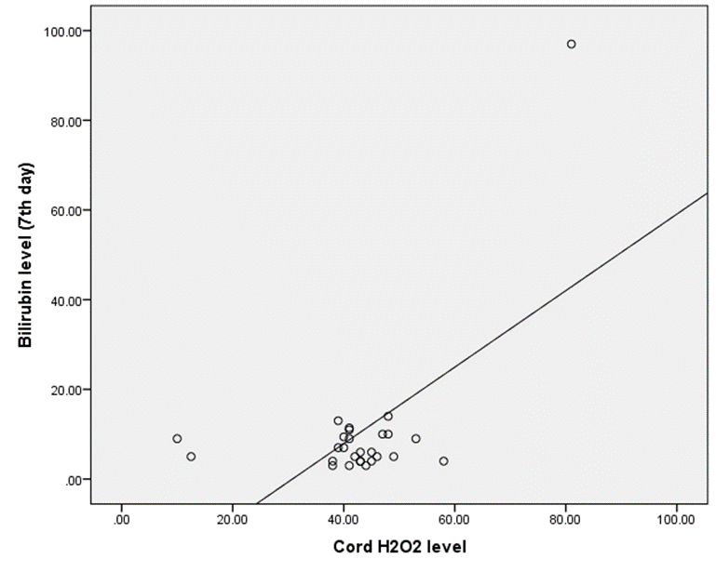

r= 0.60

P= 0.001**

**Figure (5): Correlation between cord H2O2 and bilirubin levels at the 7th day**

**Figure (6):** **Sensitivity and specificity of cord H2O2 as a predictor for neonatal indirect hyperbilirubinemia.**