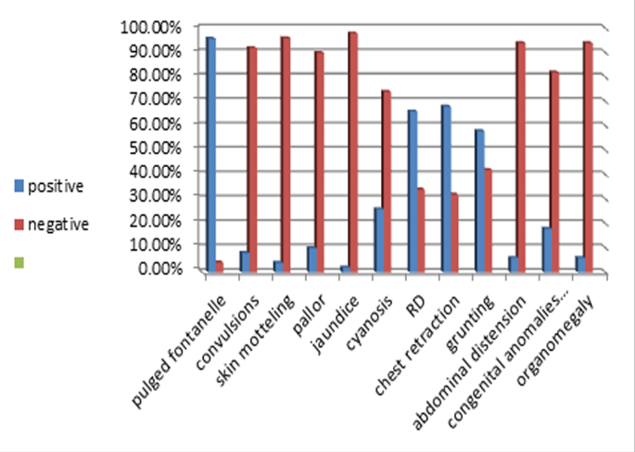
Figure (1): Some clinical signs in group I patients.

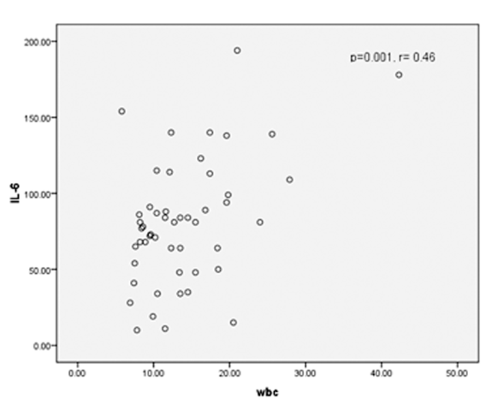

Figure(3): Correlation between WBC and IL-6.

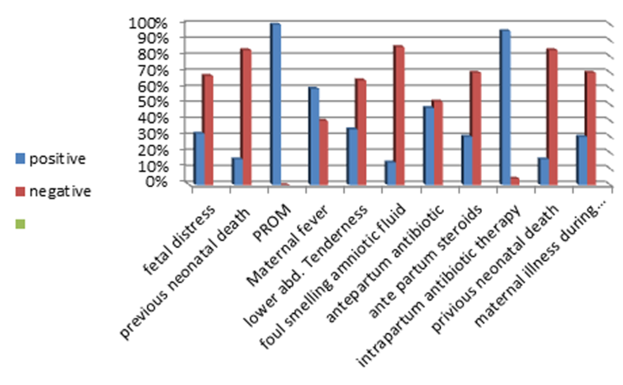
Figure (2): Frequency of some prenatal risk factor for group I patients.

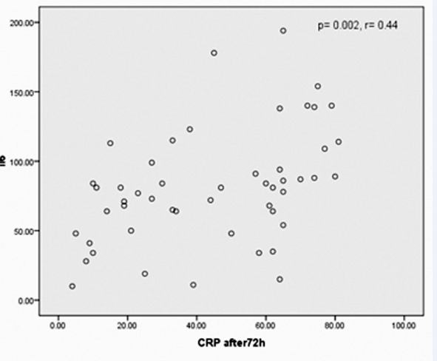

Figure(4): Correlation between CRP after 72h and IL-6.

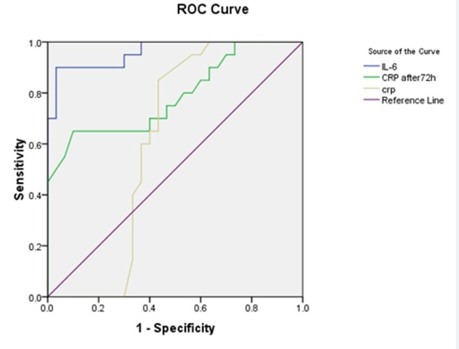
Figure (5): ROC (Receiver Operating Characteristic Curve) of IL-6 and CRP validity in group I cases.

