Figure (1): Maternal illness of stud ied group Figure (2) Maternal illness and platelets count in neonates

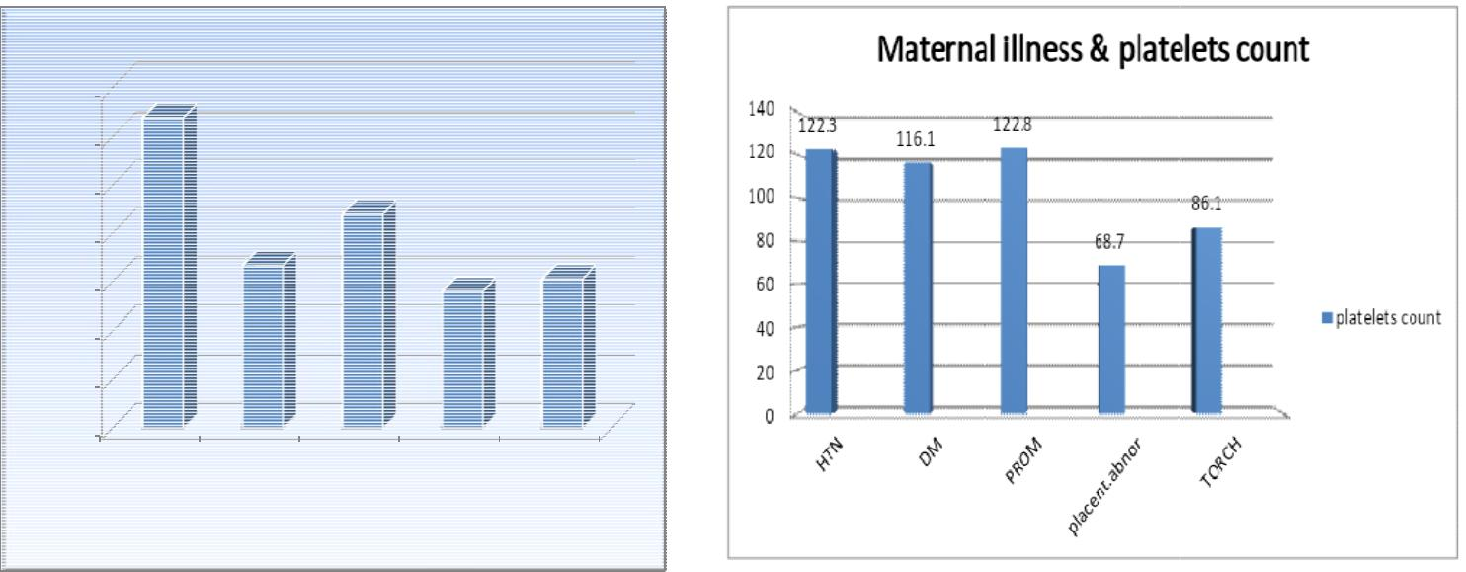

3 ³
3
0 ₂

