N.B. Dependent variable Mortality, OR odds ratio, CI confidence interval
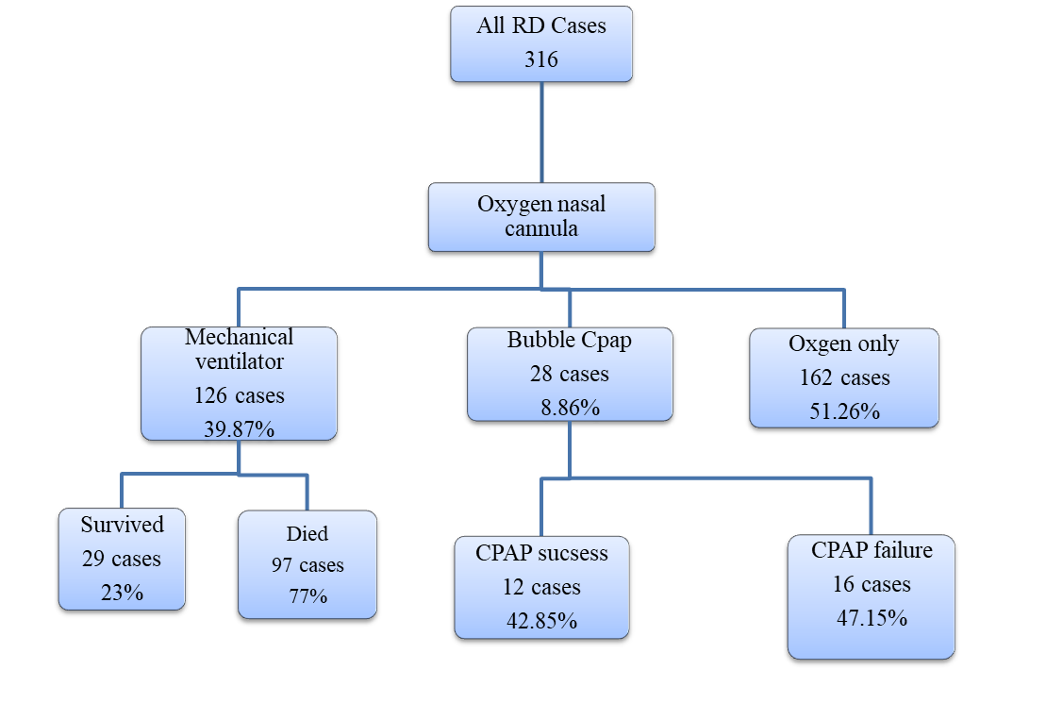
R2= 0.740

(Figure 1): "Flowchart showing distribution of the cases."

Figure (2): Relation between Gestational age and MV outcome.

Figure (3): Complication of mechanical ventilation in this study (N=126).

